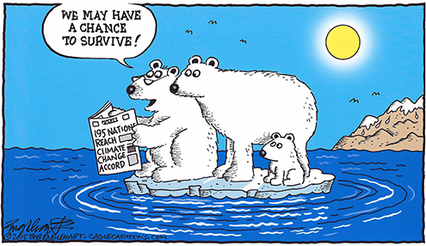

@ITHYF_Letters

How does climate change make you feel?

Climate Change makes me feel…

Because…

From ________ Year 8

Kingdown School

Warminster, UK